# Donate Today

* [Home](https://newroots.org/)
* Donate Today

# New Roots

# Annual Campaign for Individuals

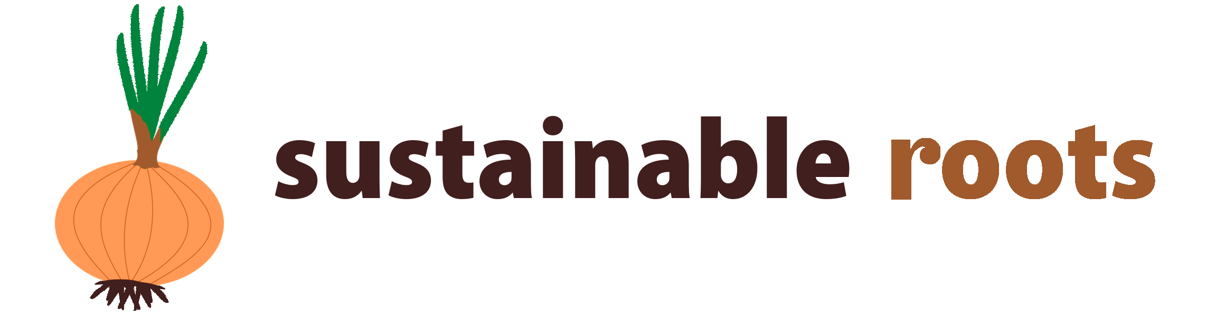

|  |
| --- |
| **Giving Level**  **\*** |
| $100 - Age of Asparagus |
| $50 - Beet Generation |
| $25 - Broc and Roll! |
| $10 - Berry Believers |

$

**Thank you for joining Sustainable Roots! Your donation today helps keep New Roots going through 2019.**

One Time Monthly

Contact Information

**Name**

First Name

Last Name

**Email**

**Address**

Address Line 1

Address Line 2

City

State/Province

ZIP/Postal Code

Country

**Phone**

**Send us a note!**

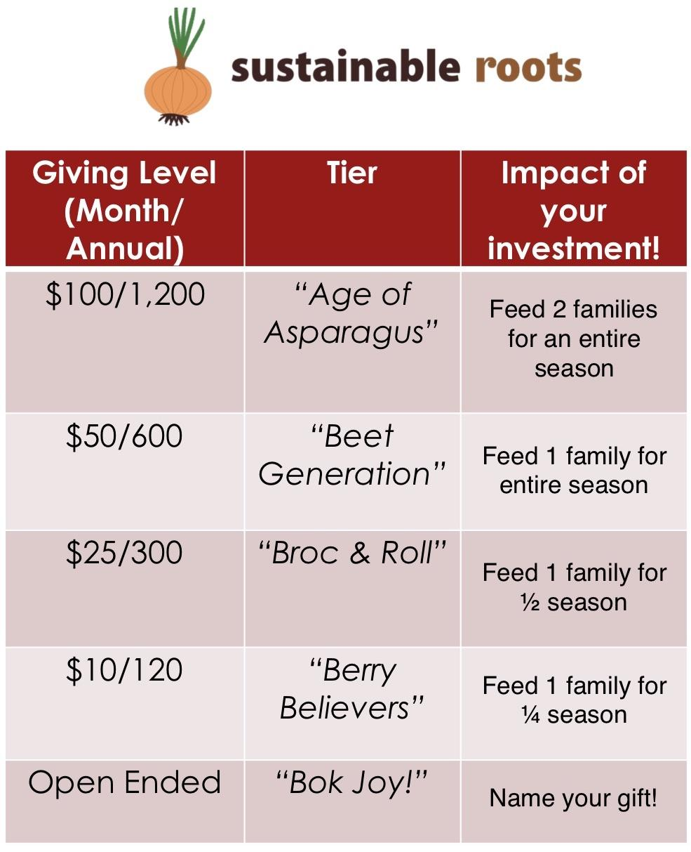

**Single-line input**

Add 3% to my total amount to help cover the payment processing fees